**PRACTICAL NO:2**

**PART A**

**CODE:**

**1)bootcat.html**

<html>

<head>

<link rel="stylesheet" type="text/css" href="bcat.css">

</head>

<title>book catlog</title>

<body id="bd" >

<table border="1" cellpadding="5" cellspacing="0" align="center" id="rcorners2" >

<caption id="cp">BOOK CATLOGUE</caption>

<tr>

<th id="h1">TITLE</th>

<th id="h2">AUTHOR</th>

<th id="h3">PRICE</th>

<th id="h4">YEAR OF BOOK</th>

</tr>

<tr>

<td>David Copperfiled</td>

<td>Dickens</td>

<td id="price1" ><img src="1.jpg"><a href="https://www.amazon.in/Copperfield-Penguin-Classics-Charles-Dickens/dp/0140439447" >500</a></td>

<td >1850</td>

</tr>

<tr>

<td>Oliver Twist</td>

<td>Dickens</td>

<td id="price2"><img src="2.jpg"><a href="https://www.amazon.in/Copperfield-Penguin-Classics-Charles-Dickens/dp/0140439447">525</a></td>

<td>1845</td>

</tr>

<tr>

<td>Emma</td>

<td>Austen</td>

<td id="price3"><img src="3.jpg"><a href=https://www.amazon.in/s?k=emma+book&i=stripbooks&ref=nb_sb_noss_1>250</a></td>

<td>1815</td>

</tr>

<tr>

<td>Hamlet</td>

<td>Shakesspere</td>

<td id="price4"><img src="4.jpg"><a href="https://www.amazon.in/s?k=hamlet+book+by&i=stripbooks&ref=nb_sb_noss_2">500</a></td>

<td>1601</td>

</tr>

<tr>

<td>Sun Also Rises</td>

<td>Hermaingway</td>

<td id="price5"><img src="5.jpg"><a href="https://www.amazon.in/s?k=sun+also+rises&i=stripbooks&crid=2QAVSJX3963W1&sprefix=sun+a%2Cstripbooks%2C295&ref=nb_sb_ss_i_2_5">450</a></td>

<td>1926</td>

</tr>

<tr>

<td>Macbeth</td>

<td>Shakespeare</td>

<td id="price6"><img src="6.jpg"><a href="https://www.amazon.in/s?k=macbeth&i=stripbooks&crid=21GIS80OANZGM&sprefix=macbet%2Cstripbooks%2C283&ref=nb_sb_ss_i_1_6">150</a></td>

<td>1603</td>

</tr>

<tr>

<td>David Copperfiled</td>

<td>Dickens</td>

<td id="price7"><img src="7.jpg"><a href="https://www.amazon.in/s?k=macbeth&i=stripbooks&crid=21GIS80OANZGM&sprefix=macbet%2Cstripbooks%2C283&ref=nb_sb_ss_i_1_6">350</a></td>

<td>1860</td>

</tr>

<tr>

<td>The fog</td>

<td>James Herbert</td>

<td id="price8"><img src="8.jpg"><a href="https://www.amazon.in/s?k=the+frog&i=stripbooks&ref=nb_sb_noss_2">500</a></td>

<td>1851</td>

</tr>

<tr>

<td>The rats</td>

<td>James Herbert</td>

<td id="price9"><img src="9.jpg"><a href="https://www.amazon.in/s?k=the+rats&i=stripbooks&ref=nb_sb_noss_2">125</a></td>

<td>1865</td>

</tr>

<tr>

<td>The Jungle Books</td>

<td>Rudyard Kipling</td>

<td id="price10"><img src="10.jpg"><a href="https://www.amazon.in/Jungle-Book-Rudyard-Kipling/dp/8172344228/ref=sr_1_3?keywords=the+jungle+book&qid=1576473665&s=books&sr=1-3">352</a></td>

<td>1871</td>

</tr>

</table>

</body>

</html>

**2)bcat.css**

table{

border-style: inset;

border-color: white;

border-width: 5px;

width: 777;

opacity:0.8;

caption-side: top;

}

tr

{

text-align: center;

color:white;

font-weight: 1000;

background-color:black;

font-family:"Times New Roman", Times, serif;

font-size:25;

cursor: pointer;

}

#h1{

font-style: calibri;

font-size: 25;

background-color: yellow;

color:black;

background-image: linear-gradient(to left,red,yellow );

}

#h2{

font-style: calibri;

font-size: 25;

background-color: orange;

background-image: linear-gradient(to left,red, orange);

color:black;

}

#h3{

font-style: calibri;

font-size: 25;

background-color: green;

background-image: linear-gradient(to left,red, green);

color:black;

}

#h4{

font-style: calibri;

font-size: 25;

background-color: lightblue;

background-image: linear-gradient(to left,red, blue);

color:black;

}

#bd{

background-image: url("book.jpg");

}

#cp{

font-size: 50;

color:darkred;

text-shadow: 0 0 3px #FF0000, 0 0 5px #0000FF;

word-spacing: 5;

background-attachment:fixed;

background-color:black;

}

#cp:hover{

background-color:white;

cursor: pointer;

background-attachment:fixed;

}

a:link{

color:green;

font-size:100;

}

a:visited{

color:red;

font-size:100;

}

a:active{

color:yellow;

font-size:100;

}

a:hover{

cursor:help;

font-size:100;

}

tr:nth-child(even)

{

background-color: grey;

color:white;

}

tr:nth-child(odd)

{

background-color:black;

color:white;

}

tr:hover{

background-color:white;

background-image: linear-gradient(red, yellow);

cursor:pointer;

color:black;

}

#price1{

border-image-repeat:norepeat;

height:200;

width:200;

}

#price2{

border-image-repeat:norepeat;

height:200;

width:200;

}

#price3{

border-image-repeat:norepeat;

height:200;

width:200;

}

#price4{

border-image-repeat:norepeat;

height:200;

width:200;

}

#price5{

height:200;

width:200;

}

#price6{

height:200;

width:200;

}

#price7{

height:200;

width:200;

}

#price8{

height:200;

width:200;

}

#price9{

height:200;

width:200;

}

#price10{

height:200;

width:200;

}

img{

max-width:190px;

max-height:190px;

}

#rcorners2 {

border-radius: 25px;

padding: 20px;

width: 200px;

height: 150px;

border-width:10;

border-color:white;

}

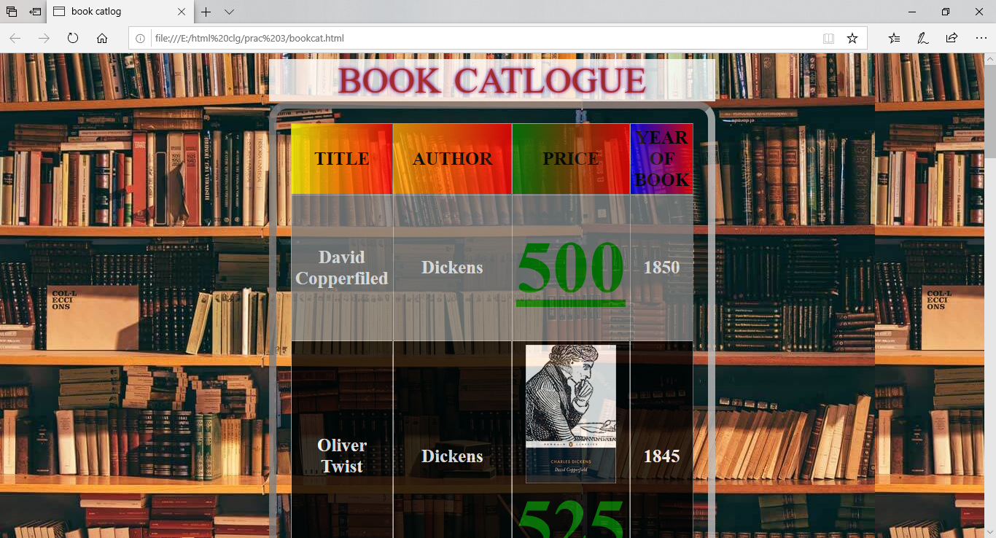**Output:**

